Reading 3

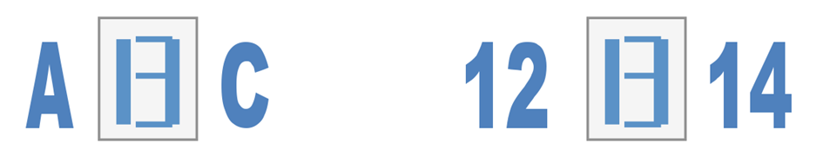Daan van der Thiel

When looking at the image you will see that it looks like the number thirteen this because you have no expectation of what it is. This is the bottom-up/ data-driven interpretation. However when you look at the examples below you will see character A the “number 13” and then character C. because this is present you expect it to be the letter B. So this influences your perception. When you will look at the example right to it you will also see it but then you will definitely think it is the number 13. This can give the viewer a wrong interpretation of the word or line given. When expectation or knowledge influences your perception it is called schema-driven/top-down interpretation.

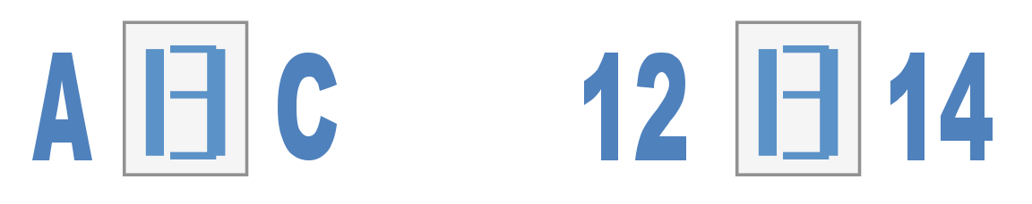

url: https://www.google.nl/search?q=bottom+up+vs+top+down+processing&espv=2&biw=960&bih=472&source=lnms&tbm=isch&sa=X&ved=0CAYQ_AUoAWoVChMIq7-pvvOFyQIVxJUPCh0ungOu&dpr=2#imgrc=nvgY8nmybg2QtM%3A